**INTRODUTION**

* 1. **Overview**

The Tableau HR Scorecard is a framework designed to measure and evaluate the success of talent, management, strategies, Stocks within an Organization.

* 1. **Purpose**

The HR scorecard is meant to leading HR

Indicators of business performance.

**PROBLEMS DEFINITION AND DESIGN THINKING**

2.1 **Empathy Map**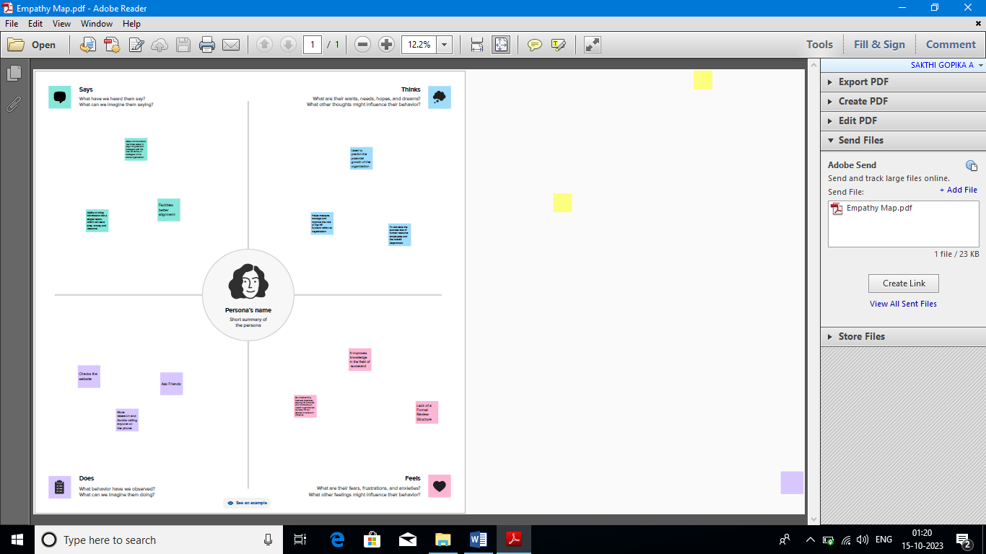

2.2 Brainstorm Map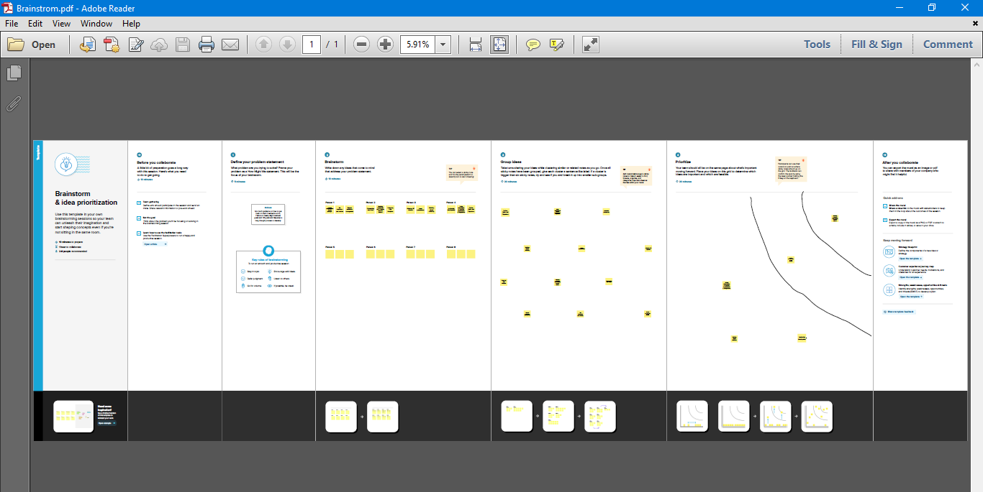

1. ADVANDAGES & DISADVANDAGES

Advantages:

* Brings structure to Business strategy.
* Make Communications Easy.
* Facilitates better Alignment.
* It must be tailored to the organization
* The ability to bring information into a single report, which can save time, money and resources

Disadvantages:

* Lack of specialization
* Measuring intangibles is difficult, if not impossible without imparting a degree of subjectivity on the part of HR staff.
* It can’t be copied precisely from examples

**4 RESULT**

Dashboard

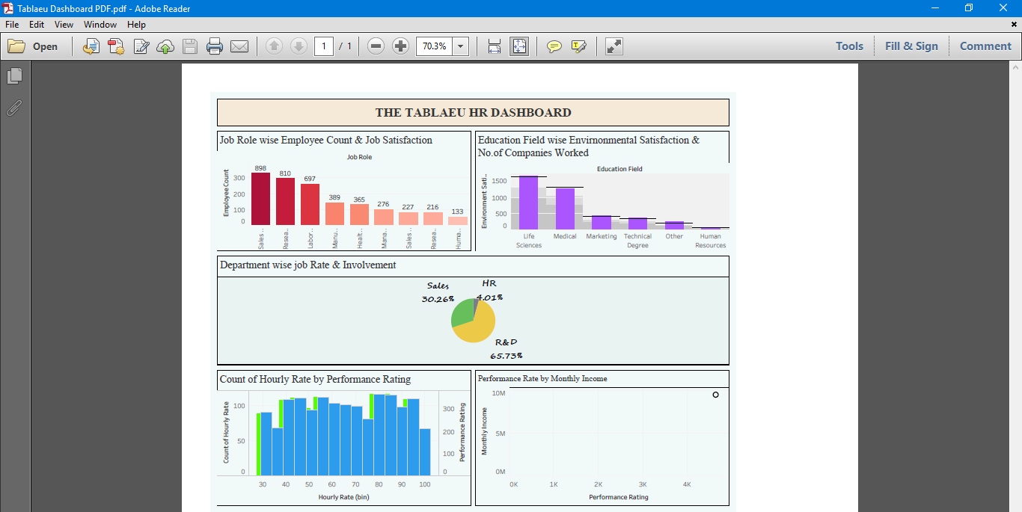

Story:

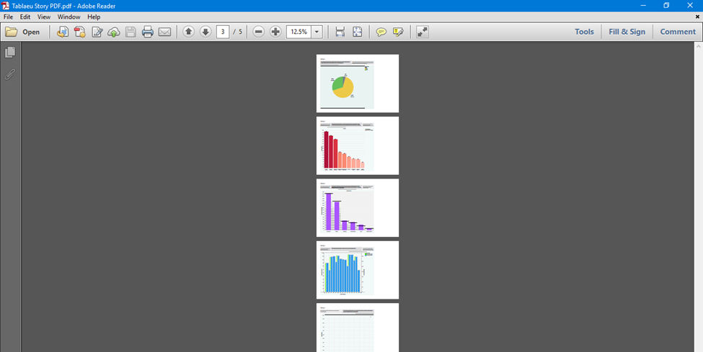

APPLICATIONS

Tableau can be used for forecasting retention by examining factors such as job satisfaction scores or whether employees feel appreciated by their managers. These metrices help predict who will leave first so that you can make adjustments before it happens.

Outcomes & Activities

The outcomes or targets of HR work

* Competence
* Commitment
* Contribution
* Organisation capability
* Leadership depth

DEVELOPMENT OF HR SCORECARD

* A financial perspective
* A customer perspective
* An internal perspective

HR employees can implement steps to align HR goals with the overall company mission, vision and business objectives.

CONCLUSION

Though the dataset is complex or the dataset is very big in tableau, we can create dashboards very easily and within less time